Contents
2.1 Service Delivery 2
Detailed plan: trained engineers, competence assurance and performance management 2
A service built around competent people 2
Recruitment and development before independent deployment 3
Named UK engineering capability 4
Recurring certified training and technical development 6
Competence-led allocation and live field support 6
Performance monitoring throughout the contract 7
Intervention, resilience and continual improvement 7

2.1 Service Delivery
Pulse Fitness will deliver this agreement through a named, directly employed and directly managed UK engineering team, supported overseas by vetted, Congleton-trained engineers and by direct UK deployment where specialist support is required. Every engineer is allocated within demonstrated competence, supported live by Head Office, and monitored through response, completion, repeat-fault, quality, safety, customer and reporting measures.

Detailed plan: trained engineers, competence assurance and performance management
Tender question: Demonstrate, via a written plan, how appropriately trained and skilled engineers will be used to deliver this requirement, and how performance is monitored and managed.
Scoring focus: Required certification and training; management of directly employed and third-party engineers; performance monitoring throughout the contract; supported by a clear process map.

14 | 141 | 9 | 1
current UK engineers | combined years of experience | certified annually recurring courses | controlled competence process

A service built around competent people
Pulse Fitness understands that the quality of this contract will ultimately be judged by the engineer who arrives at the MOD site. That engineer must be technically capable, properly prepared, safe in their working methods, confident with the customer and supported well enough to make the correct decision first time. Our plan is therefore built around competence-led allocation rather than a "nearest available engineer" model.
The Service & Aftersales Manager retains responsibility for engineer allocation and performance. The MOD service team validates the purchase order, equipment, access requirement, likely parts and response priority before assigning the work. Where an engineer needs additional support, Pulse Fitness can provide live technical advice, reallocate the task to a more appropriate colleague, or combine regional response with national specialist resource. Contractual accountability always remains with Pulse Fitness.
This matters on a mixed-brand defence estate. A general geographical allocation may suit routine inspection, but a complex treadmill drive fault, an obsolete console, a structural concern or work aboard a vessel can require a different skillset. Pulse Fitness makes that decision before attendance wherever possible, using the asset history and fault evidence held in MODService and Pulse Fitness’s internal service systems.
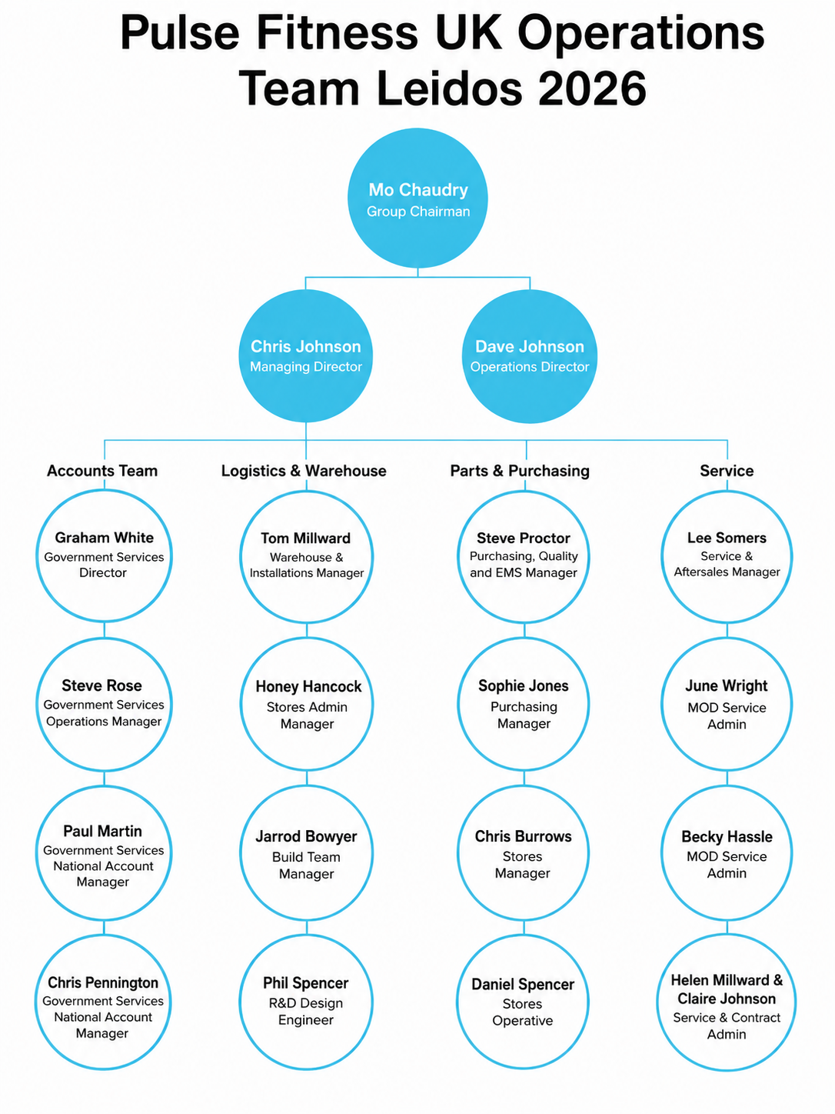
Figure 1, Pulse Fitness UK service operations and escalation structure (Pulse Fitness, 2026).
What the figure shows: The organisation chart sets out the central service, technical, stores and engineering resources that support the agreement, showing that field engineers sit within a wider operating structure rather than working as isolated regional resources.
Why it matters to the MOD: The Authority receives one accountable service route. Scheduling, technical decisions, stock, customer communication, quality review and recovery can all be escalated quickly without transferring responsibility between disconnected suppliers.

Recruitment and development before independent deployment
Pulse Fitness recruits for both technical capability and customer judgement. Candidates are expected to demonstrate an appropriate mechanical, electrical, electronic, mechatronic or engineering-maintenance background, but qualification alone is not treated as proof of field competence. We also assess practical fault-finding, safe working, organisation, communication and the ability to represent Pulse Fitness professionally in a MOD environment.
New engineers complete a structured four-week in-house programme at Congleton using live cardiovascular, strength, free-weight and functional equipment. The programme combines equipment theory with strip-down and rebuild, diagnostics, mechanical and electrical checks, parts identification, service reporting, customer conduct and safe isolation. Engineers then work alongside a senior engineer for a further six to eight weeks, with task complexity increased only as evidence of competence is gathered.
Final-stage recruitment includes a practical assessment observed by the Commercial Director, so an offer is only made once an engineer has demonstrated hands-on competence rather than interview performance alone.
Independent allocation is authorised by equipment and task family. An engineer may be approved for planned servicing and common repairs while still requiring support for a specialist electronic, structural or software fault. Authorisation remains visible to the Service & Aftersales Manager and can be extended, restricted or suspended in response to training, audit and field performance.

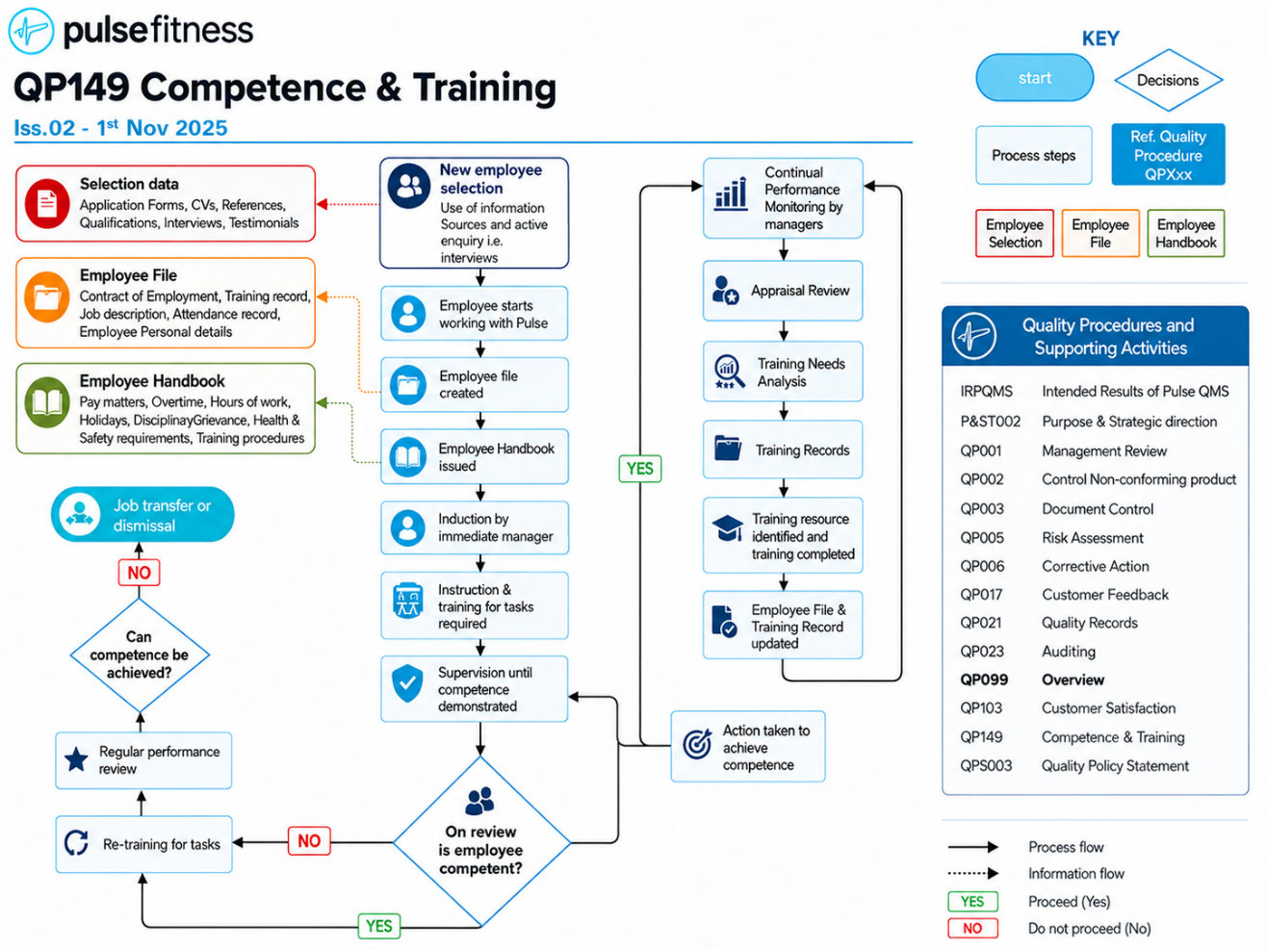
Figure 2, QP149 Competence & Training process (Issue 02, 1 November 2025).
What the figure shows: QP149 follows the engineer from selection through induction, supervised activity, competence assessment, training records, periodic review and corrective action, linking each individual’s approved scope to the evidence that supports it.
QP149 is a controlled procedure maintained under Pulse Fitness's ISO 9001:2015 quality system and is reviewed annually, keeping the competence process current alongside its companion procedures.
Why it matters to the MOD: The process prevents an engineer being released solely because training has been attended. Competence must be demonstrated, recorded and maintained, giving the MOD a controlled route from recruitment to authorised field delivery.
Engineer competence and service delivery are supported by Pulse Fitness’s ISO 9001:2015 Quality Management System, certified by NQA under UKAS accreditation. The certified scope specifically includes the design, procurement, assembly, supply, installation, service and maintenance of leisure equipment, ensuring that engineer training, competence records, service processes, quality controls and continual improvement operate within an independently accredited management framework. This provides Team Leidos and the MOD with additional assurance that the engineering capability described within this plan is not managed in isolation, but forms part of a controlled and externally certified quality system.

Named UK engineering capability
The current UK team provides coverage across Great Britain and Northern Ireland and combines 141 years of fitness-equipment engineering experience. Individual experience ranges from two to twenty-two years, with an average of approximately ten years. The team holds formal mechanical and electrical qualifications, 18th Edition knowledge, gym-equipment installation experience and extensive practical work across Pulse Fitness and third-party products.
Pulse Fitness does not claim that every engineer holds every qualification. The strength of the network is that each job can be matched to the right combination of equipment knowledge, geography, access and task risk, while the customer continues to deal with one central service operation.

Engineer | Base | Years | Qualification / technical background
Jim Harper | Catterick | 5 | City & Guilds motor vehicle; plant operations NVQ; 18th Edition
Aidan Greig | Aberdeen | 8 | Level 3 Personal Training; IOSH Working Safely
Billy Dean | Hatfield | 4 | City & Guilds Level 3 Electrical Installation
Lee Blakeman | Talke | 22 | Level 3 Technical Services; Gym Equipment Installation
Conrad Williams | Croydon | 3 | Incident Support Engineer NVQ; Fibre Engineer NVQ
Kieran Pearce | Weybridge | 2 | NVQ Level 4 Mechanical Engineering
James Ignaciuk | Cleckheaton | 8 | Pulse internal field-service and mixed-brand competence
Marcus Turner | Harwich | 15 | Level 4 Mechanical Engineering
Craig Fisher | East Kilbride | 4 | NVQ Electrical Installation
Ryan Somers | Walsall | 15 | Level 3 Plumbing; extensive PTE service experience
William Ollis | Keynsham | 8 | Pulse internal field-service and mixed-brand competence
Dave Mathias | Swindon | 12 | Level 4 Mechanical Engineering
Lee Somers | Dudley | 15 | Electrical Installation; technical escalation and service leadership
Alan Herron | Kilkeel | 20 | Electrical Installation; Level 4 Mechanical Engineering

All fourteen engineers are recorded as having completed Pulse Fitness internal field-service training, holding a full driving licence and Enhanced DBS status, and having mixed-brand experience across Pulse Fitness, Technogym, Matrix, Wattbike, Origin and Life Fitness. These records are retained in the controlled competence matrix and can be produced during audit or mobilisation.
Wider engineering support from Congleton: the fourteen field engineers are supported by the wider Congleton team, including service coordination, stores and parts, technical support, design, and quality and administration. These office-based colleagues provide diagnostics, parts identification, documentation and escalation behind every visit. They are not counted as field engineers, but their skills in technical support, parts management, quality assurance and service planning are integral to safe, first-time delivery.

Recurring certified training and technical development
Technical competence is supported by a recurring safety programme, because the engineer must be able to work safely in very different environments: busy gym floors, rehabilitation facilities, accommodation areas, vessels, stores and overseas sites. Course validity is monitored by the Service and HR teams against the certificate or controlled training requirement; we do not assume that every course carries the same expiry cycle.
Certified course | Operational relevance
Slips, Trips and Falls | Safe movement around equipment and customer areas
Working at Heights | Safe access and work above ground level
Risk Assessment Awareness | Dynamic and task-specific assessment
Fire Extinguisher Use | Emergency response and extinguisher selection
Manual Handling | Safe movement of equipment, components and tools
COSHH Awareness | Control of cleaners, lubricants and chemicals
Ladders and Stepladders | Safe selection and use of access equipment
CPR Awareness | Immediate emergency-response awareness
Driving at Work Essentials | Occupational driving and journey-risk control
The submission uses a representative sample rather than reproducing every individual certificate. The full register remains available for clarification and audit, including employee name, presentation date, validity and CPD evidence.
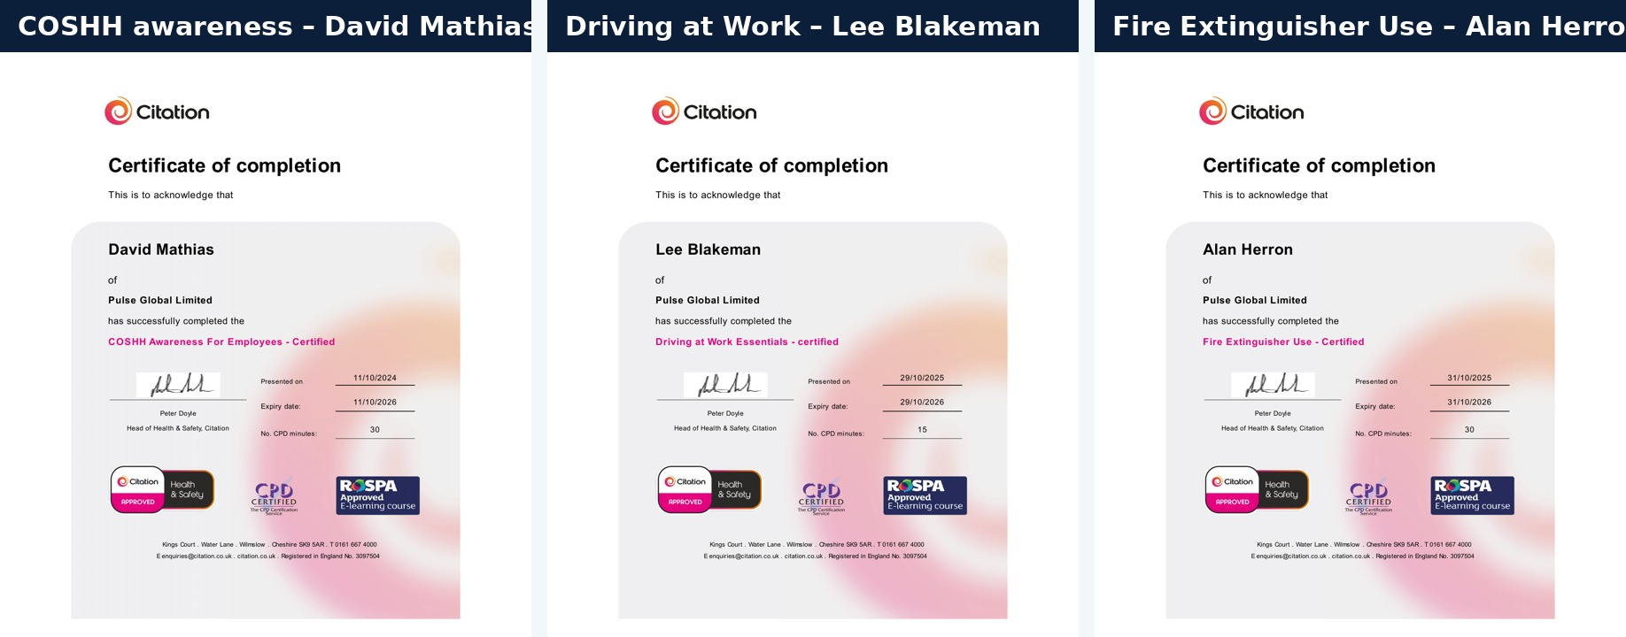
Figure 3, Representative certified training evidence (Citation, CPD-certified).
What the figure shows: Named examples of COSHH Awareness, Driving at Work Essentials and Fire Extinguisher Use certification, each showing a presentation date, expiry date and CPD record.
Why it matters to the MOD: The sample demonstrates that the stated programme is live and externally certified. The full workforce register allows Pulse Fitness to monitor renewal and prevent expired training from being overlooked.
Formal certification is reinforced by regular operational learning. Pulse Fitness holds an engineering Toolbox Talk every other Friday, giving the service and technical teams a structured opportunity to brief engineers on current safety matters, service observations, recurring faults, product updates and changes to working practices. Where an engineer identifies a recurring failure, an unusual fault or a safer working method, that experience is shared with the wider team and reflected in technical guidance, van stock, service procedures or further training.
Engineer competence is reviewed on a defined cadence: fortnightly Toolbox Talks, quarterly technical refresher sessions covering new and existing equipment, strip-down and rebuild, fault diagnosis, new component identification, console or software changes and safe adjustment, and an annual competence review recorded against each engineer's authorised scope. Refresher content is informed by service data, so repeat faults, incorrect parts, technical escalations and warranty trends convert directly into practical engineer development, reinforcing QP149 rather than competing with it.

Competence-led allocation and live field support
Before travel, the engineer receives the site, contact, asset, fault description, photographs, previous service history, warranty or contract position and any known parts requirement. This preparation is used to select both the engineer and the likely van or centrally supplied stock. Where information is incomplete, the service team contacts the site or uses remote video diagnostics before committing avoidable travel.
Engineers remain connected to Congleton throughout the visit. Technical discussions take place by telephone, approved business messaging or email with service, design, technical and stores colleagues. Photographs and video can be reviewed while the engineer is beside the equipment, allowing product codes, wiring, safe next steps and parts to be confirmed quickly. Formal instructions, decisions and evidence are then retained through Pulse systems, MODService portal and the agreed contract channels.
The same control applies to third-party overseas engineers. Each dealer organisation is vetted, must hold at least five years’ commercial fitness-equipment experience, and sends its engineers to Pulse Fitness in-house dealer training at Congleton. Local responsiveness is therefore supported by direct manufacturer knowledge and one central escalation route.
Where a task falls in an operational area, allocation also requires current CONDO certification and any security clearance agreed and sponsored with Team Leidos. The competence matrix records CONDO status alongside equipment authorisation, and the supporting route is set out at 2.3A.

Performance monitoring throughout the contract
Pulse Fitness will monitor the service at engineer, region, equipment and contract level. The purpose is not simply to report historic performance; it is to identify the next risk early enough to act. Open jobs, response risk, parts dependency and capacity are reviewed weekly. Contract measures, repeat faults, customer feedback and quality exceptions are reviewed monthly. Competence, recurring technical issues and authorisation scope are reviewed quarterly.
Performance against the contractual KPIs: the engineer performance system is measured directly against the three key performance indicators at Annex B.
KPI 1, confirmation of service or delivery date: Pulse Fitness confirms that the requested service or delivery date can be met within 48 hours of the request, against a target of 95%, monitored from the purchase-order timestamp in the Service Portal and reported monthly.
KPI 2, meeting agreed time schedules: work is delivered on time and to the required standard against a target of 100%, evidenced by job completion and customer sign-off. Overseas requests are acknowledged within 48 hours, an obligation delivered at 100% under the comparable contract LSL/DC/0186 (cross-referenced at 2.2B and 2.3B), with a scheduled timeframe then provided within five working days.
KPI 3, monthly management information: Pulse Fitness provides monthly management information to Team Leidos by the fifth day of the following month against a target of 100%, reported through the agreed contract reporting route.
If performance falls below these levels, the Service & Aftersales Manager triggers proportionate remedial action: reallocation to a neighbouring engineer, targeted retraining at the next Toolbox Talk or quarterly refresher, van-stock adjustment and, where required, a corrective action logged under the quality system. Findings from the weekly service review, repeat-fault analysis and customer feedback feed directly into these interventions, closing the loop between performance data and field delivery.
Measure | How Pulse Fitness manages it
Response and attendance | PO receipt, site contact, promised date and arrival are monitored; at-risk jobs are escalated before breach.
Single-visit completion | Completion in one visit is analysed separately from parts, access and customer-dependent returns.
Repeat fault / repeat attendance | A repeated asset, symptom or component triggers root-cause, design, stock or coaching review.
Planned service and evidence quality | Inspection completeness, service certificate, serial, red label, condition and advisory notes are checked.
Customer feedback and conduct | Positive and negative feedback is reviewed with the engineer and actions are documented.
Stock and parts accuracy | Van use, replenishment, wrong-part events, returns and controlled-parts traceability are monitored.
Safety and quality | Incidents, near misses and non-conformances trigger containment, investigation and corrective action.

Intervention, resilience and continual improvement
Where performance falls below expectation, Pulse Fitness intervenes at the appropriate level. A minor reporting gap may require immediate coaching and evidence correction; a recurring technical issue may require a product bulletin and stock change; a safety, conduct or material quality concern can result in the engineer’s allocation being suspended while the matter is reviewed. The response is proportionate, documented and focused on preventing recurrence.
Regional coverage is reinforced by neighbouring engineers, national deployment and overnight stays where a site falls outside the normal operating radius. The engineer nearest to a site is not automatically chosen if another engineer is more likely to complete the task safely and effectively. This gives Pulse Fitness the resilience to manage leave, sickness, workload surges and specialist faults without lowering the competence standard.
For overseas and operational deployments, Pulse Fitness will use military transport where it is available and economical, confirmed with the ordering Authority before travel.

CONTRACT ASSURANCE: Pulse Fitness remains responsible for every engineer and lower-tier provider used on the agreement. Competence is confirmed before allocation, supported during the task, evidenced at closure and continually improved through performance, quality, customer and parts information.

This plan gives Team Leidos and the MOD a named, qualified and directly managed engineering capability; a controlled route from recruitment to authorisation; live technical and parts support; and a performance process that turns real service information into corrective action. It is designed to maintain a consistent standard regardless of engineer, equipment manufacturer or location.

